

East West University

Department of Computer Science & Engineering

**Course Title:** Database System

**Course Code:** CSE301  
**Experiment No:** 05

**Semester:** Fall, 2015

**Section:**01

**Submitted By:**

S. M. Amirul Islam

ID: 2013-1-60-048

**Introduction**

We can add, delete or update information on database by using some commands.

# **Create the table employee.**

createtableemployee(

enamevarchar(20),

streetvarchar(20),

cityvarchar(20)

)

Snapshot:



**#insert values in it:**

insertintoemployee(ename,street,city)values('Rahim','X','Dhaka');

insertintoemployee(ename,street,city)values('Mitu','Y','Sylhet');

insertintoemployee(ename,street,city)values('Sabbir','Z','Ctg');

insertintoemployee(ename,street,city)values('Babu','P','Dhaka');

insertintoemployee(ename,street,city)values('Toma','X','Bogra');

insertintoemployee(ename,street,city)values('Jabbar','X','Comilla');

Snapshot:

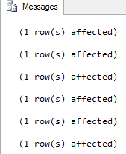

Output snapshot:

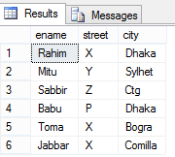

# **Create the table works:**

createtableworks(

enamevarchar(20),

cnamevarchar(20),

salaryint,

jdatedatetime

)

**Snapshot:**



**#insert values in it:**

insertintoworks(ename,cname,salary,jdate)values('Rahim','First B.C',20000,'8/8/2008');

insertintoworks(ename,cname,salary,jdate)values('MItu','Small B.C',30000,'8/13/2008');

insertintoworks(ename,cname,salary,jdate)values('Sabbir','Square Pharma',40000,'9/17/2009');

insertintoworks(ename,cname,salary,jdate)values('Babu','GP',50000,'12/13/2009');

insertintoworks(ename,cname,salary,jdate)values('Toma','Square Pharma',35000,'10/10/2010');

insertintoworks(ename,cname,salary,jdate)values('Jabbar','First B.C',15000,'4/4/2009');

**Snapshot:**



Output snapshot:

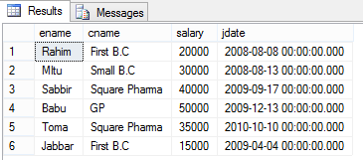

# **Create the table company:**

createtablecompany(

cnamevarchar(20),

cityvarchar(20)

)

**Snapshot:**



**#insert values in it:**

insertintocompanyvalues('First B.C','Dhaka');

insertintocompanyvalues('Small B.C','Sylhet');

insertintocompanyvalues('Square Pharma B.C','Ctg');

insertintocompanyvalues('GP','Rajshahi');

**Snapshot:**

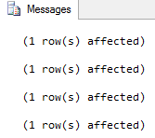

**Output Snapshot:**

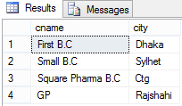

**# create the table manages:**

createtablemanages(

enamevarchar(20),

mnamevarchar(20)

)

**Snapshot:**



**Insert values in it:**



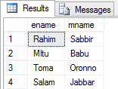

**Q1. Delete information of company which situated at Dhaka.**

**SQL:** deletefromcompanywherecity='Dhaka'

select*fromcompany

**Output:**



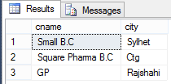

**Q2. Delete information from work table for the employee whose salary is less than 20000.**

**SQL:** deletefromworkswheresalary<20000

select*fromworks

**Output:**



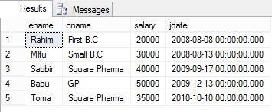

**Q3. Delete from employee whose street is x.**

**SQL:** deletefromemployeewherestreet='X'

select*fromemployee

Output:



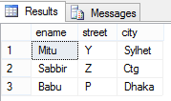

**Q4.Delete record from works that contains employee live in Rajshahi.**

**SQL:** deletefromworkswhereenamein(selectenamefromemployeewherecity='Rajshahi')

select*fromworks

Output:



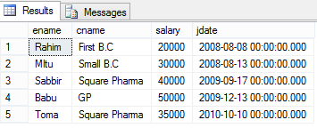

**Q5. Delete record from employee who works for ABC company.**

**SQL:** deletefromemployeewhereenamein(selectenamefromworkswherecname='ABC')

select*fromemployee

**Output:**



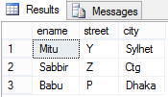

**Q6. Delete from works where manager names is Sabbir.**

**SQL:** deletefromworkswhereenamein(selectenamefrommanageswheremname='Sabbir')

select*fromworks

**Output:**



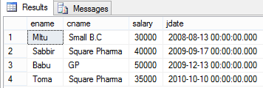

**Q7. Give all employee of First B.C Corporation are 10% salary raise.**

**SQL:** updateworkssetsalary=salary*1.1 wherecname='First B.C'

select*fromworks

**Output:**

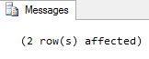

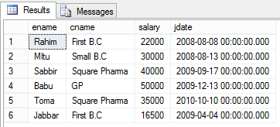

**Q8. Give all managers in the database a 10% salary raise.**

**SQL:** updateworkssetsalary=salary*1.1 whereenamein(selectdistinctmnamefrommanages)

select*fromworks

**Output:**



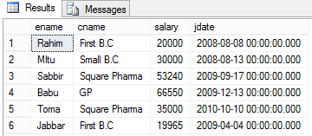

**Q9. Increase the salary of employee by 10% for the companies those are located Bogra.**

**SQL:** updateworkssetsalary=salary*1.1 wherecnamein(selectcnamefromcompanywherecity='Bogra')

select*fromworks

**Output:**



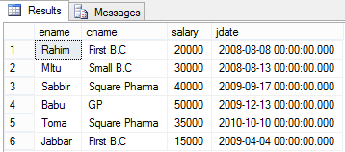

**Q10. Modify the DB so that Rahim now lives in Bhola.**

**SQL:** updateemployeesetcity='Bhola'whereename='Rahim'

Select*fromemployee

**Output:**



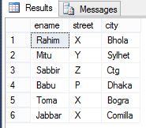

**Q11. Give all managers in this database a 10% of salary increase unless the salary after increment would be greater than 100000, in such cases give only a 3% raise of salary.**

**SQL:** updateworkssetsalary=case

whensalary*1.1>100000 thensalary*1.03

elsesalary*1.1

end

whereenamein(selectdistinctmnamefrommanages)

droptableworks

select*fromworks

**Output:**

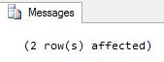

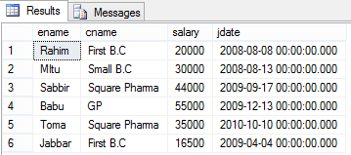

**Discussion:** In this lab we have learnedhow to update a databaseusing database management system tools.